ETS Proficiency Profile
What is the ETS Proficiency Profile?
The ETS Proficiency Profile is a test of general academic knowledge and skills. It includes material covered in general education courses and is intended for use by colleges and universities to assess and improve the quality of instruction and learning in general education programs.
How long is the test?
The test is 36 questions and should take no longer than 45 minutes to complete.
How is it scored?
Scores are based on the number of questions answered correctly. There is no penalty for guessing, so you should try to answer every question.
What skills does the test measure?
The ETS Proficiency Profile is designed to measure students’ skills in reading, critical thinking, writing, and mathematics.
What scores will be reported to students?
You will receive a total score on a scale of 400-500. Because TESU is focused on the performance of the institution as a whole, your test scores will be averaged with those of other TESU students and this average will become the primary unit of analysis.

Instructions
Please note: So that the University can properly partition the aggregated scores based on various demographic factors and by degree program, you will be asked to provide some basic information at the beginning of the test. You will need to know your Student ID number, the name of the degree program in which you are enrolled, and the school with which your degree program is associated.
Before taking the test, please follow the instructions below to obtain your University Student ID number if you do not already know it.
- Login to Online Student Services, which you can access through the student portal.
- Select “Students Click Here”
- Under Academic Profile, select “My Student ID” and click continue.
Once you know your student ID number and are ready to take the exam, please follow the instructions below.

Preparing your Computer for the Test Administration
- Run a system check
  - Go to etsreadiness.ets.org/
  - Review the ETS Proficiency Profile system requirements then select Check Readiness.
  - You may be prompted to link your device to your institution. Select Skip This Step and then Continue. You do not need to enter a Username.
  - Select Run System Check.
  - Enter the information requested and select Run Check.
  - Follow the instructions on the screen to correct any issues detected.
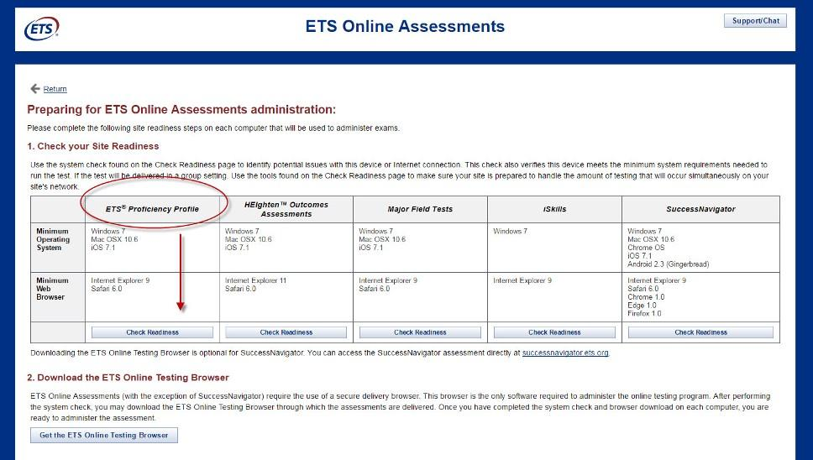
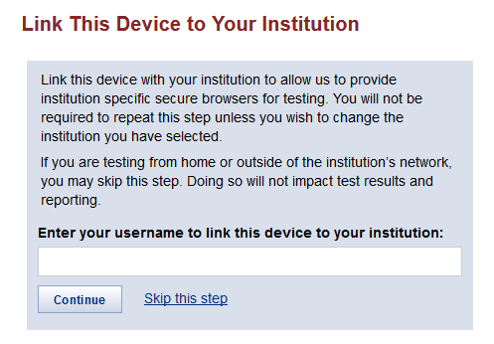

- Download the ETS secure testing browser.
  - If you are still on the System Check Results page, select Download and save the browser to your desktop
Or
- If you are no longer on the System Check Results page, go to etsreadiness.ets.org/ and select Get the ETS Online Testing Browser.
- Select Download and save the browser to your desktop
Note: Completing the system check and downloading the secure browser can be completed prior to your planned testing time.

If you encounter any problems, please contact ETS Technical Support at 1-800-514-8491 or by email at ProficiencyProfileSupport@testsys.com. Alternatively, you can click the Support/Chat button in the upper right hand corner of your screen to request help. Business hours are 8:00 A.M. to 6:00 P.M. (Eastern Time). If you need help outside of those hours, call 1-800-514-8491 and select the option for after-hours assistance.
If you contacted ETS Technical Support and you are still having technical issues, please file a TESU helpdesk ticket with the letters “ETS” in the title of the helpdesk ticket request. By indicating you are having an ETS-related issue, this will ensure the ticket is properly routed to the appropriate department to help solve your problem as quickly as possible.

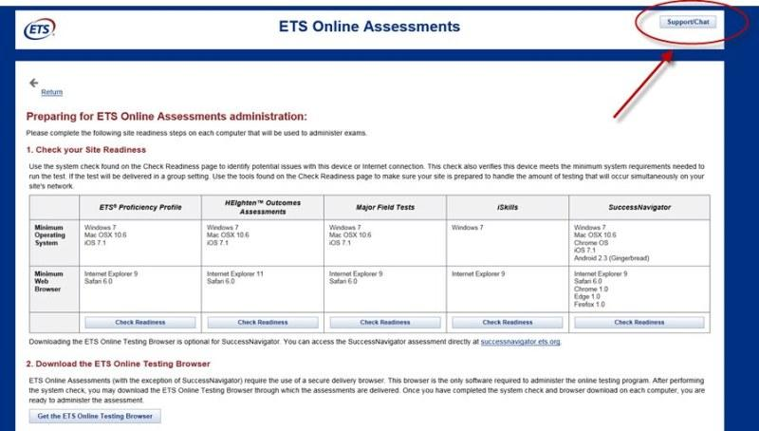

Taking the Test
(Windows or Mac Operating Systems)
While not required, you may want to have scratch paper, pencils, and a calculator available for use. Other study aids are not permitted.
When you are ready to begin the test, close all open applications on your computer and turn off or disable all pop-up blockers.
- Click on the ETS Online Testing Browser icon on your desktop.
- When prompted, enter the following Session Number: 130298-148885084
- Next, complete the login information. If you are logging in for the first time, enter your email address on the login screen and select the radio button next to “No, I have not logged in before” and then click Submit.
- Complete your personal profile and then click Submit, which will direct you to the testing homepage.
- Click the Start Online link on the testing homepage.
- Complete the tutorial and sample assessment to familiarize yourself with the format of the test. Click End when you have completed the sample assessment. Click OK on the dialog box that appears to confirm that you are finished with the sample assessment.
- Click Next to begin the assessment.
The ETS® Proficiency Profile is a timed assessment. If you do not complete the assessment in the designated time (40 minutes), a message box will display and the assessment will automatically be scored. Make sure you monitor the time remaining by checking the timer in the upper right corner of the screen. Note: Do not click the “Exit” button until you have completed the assessment and are ready to submit your assessment for scoring.
- When you have completed the test, click Exit.
- Click Logout to exit the administration window and conclude the assessment. You’re all done!

If you encounter any problems, please contact ETS Technical Support at 1-800-514-8491 or by email at ProficiencyProfileSupport@testsys.com. Business hours are 8:00 A.M. to 6:00 P.M. (Eastern Time). If you need help outside of those hours, call 1-800-514-8491 and select the option for after-hours assistance. If you contacted ETS Technical Support and you are still having technical issues, please file a TESU helpdesk ticket with the letters “ETS” in the title of the helpdesk ticket request. By indicating you are having an ETS-related issue, this will ensure the ticket is properly routed to the appropriate department to help solve your problem as quickly as possible.
Don’t forget: To receive credit for completing the ETS Proficiency Profile, post a comment about the test and your experience taking it to the ETS Proficiency Profile discussion forum. In your posting, indicate the date on which you took and completed the test. For students taking a Guided Study version of the course, you may be asked to submit this information as an assignment instead of posting it to a discussion forum. Your mentor will verify your participation and will give you credit for it. Upon completing the test, you will receive a confirmation email from ETS. Retain this email for your records as verification that you completed the test.

